**##Marvel and DC Universe: Interactive Web Dashboard**

​

**##Summary**

​

We have compiled data to do a through analysis of all superheroes in the universe, to help determine which current world issue they can potentially assist with (willingly).

​

**##Group Members**

​

* Ryla Almario

* Tamala Chipeta

* Andrew Lau

* Mitesh Parekh

​

**## Motivation**

​

With the current state of the world, it is only inevitable before superhero (and unfortunately villain) intervention will be required. To help save us all, a thorough analysis of all heroes and villains is required to figure out which superheroes will potentially be the most helpful, and the way they can help most effectively (does anyone’s blood have the cure for COVID, can we make everyone colorblind, etc).

**###Workflow Chart**

​

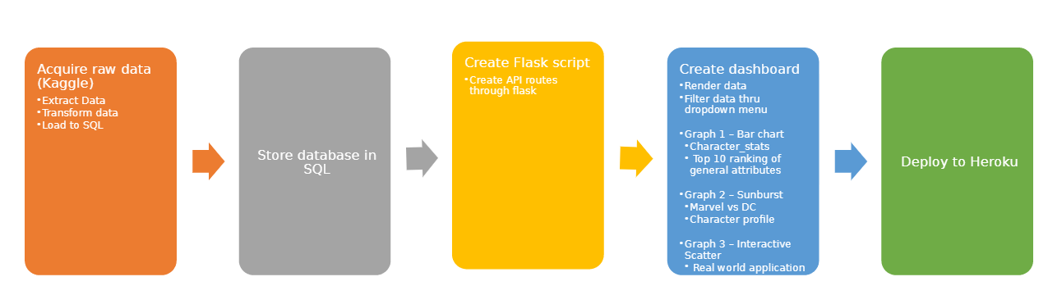

**### Visualization Examples for Inspiration**

​

*Bar Chart sorting top Superheroes by Stats

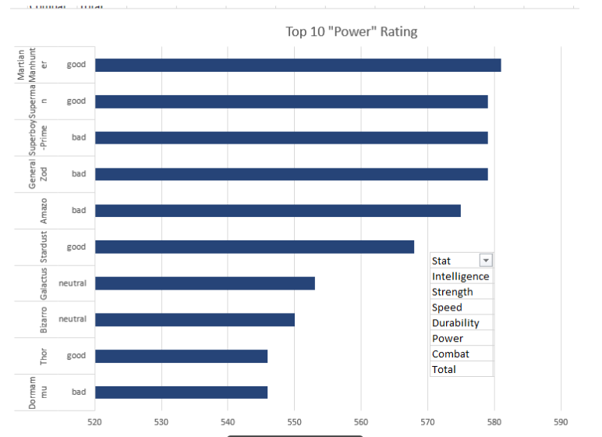

*Sunburst based on Marvel vs DC and good vs bad, showing hero/villain attributes

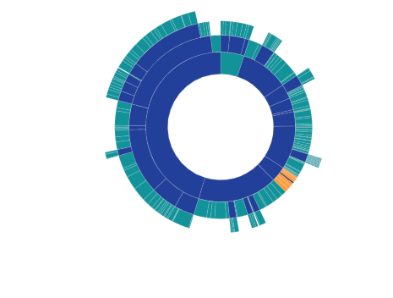

*Interactive Scatter Plot based on relevant attributes to help current real world issues

​

**## Sources**

​

* Kaggle: CSV Files:

*API: Superheroapi.com

​

​

**##Sketch of website**

